IOT BASED ALERT SYSTEM TO HIGHLIGHT PROCESS FAILED

Business Requirements Document

Votary Softech Solutions Pvt. Ltd.

Plot No: 76, Lumbini layout,  
Near Euro school,  
Gachibowli-I (V), Hyderabad,  
Telangana - 500032,  
India.

**Revision History**

|  |  |  |  |  |  |
| --- | --- | --- | --- | --- | --- |
| Version (x.y) | Date of Revision  (DD-MM - YYYY) | Description of Change | Reason for Change | Affected Sections | Approved By |
| 1.1 | 21-07-2017 | Added Build Success case |  | 2.1  4  5.1 |  |
|  |  |  |  |  |  |
|  |  |  |  |  |  |

**Approval History**

|  |  |  |  |
| --- | --- | --- | --- |
| Version (x.y) | Prepared By | Reviewed By/Date | Approved By/Date |
| 1.0 | Arun Nalam |  |  |
|  |  |  |  |
|  |  |  |  |

**Contents**

1 Define 4

1.1 Objective 4

1.2 Deliverables 4

1.3 Prerequisites 4

1.4 Assumptions 4

1.5 Limitations 4

1.6 Business Risks 4

1.7 Glossary 4

2 Specify 4

2.1 Scope 4

2.2 Schedule and Milestones 4

2.3 Resources 4

2.4 Cost 4

2.5 Market Analysis 5

2.5.1 Competitor Information 5

2.5.2 Substitutes in Market for Product 5

2.5.3 Targeted Domains 5

3 Architecture 5

3.1 Block Diagram 5

3.2 Internal Interfaces 5

3.3 External Interfaces 5

4 Design 5

4.1 Flowcharts 5

4.2 Development Environment 5

4.3 IP Identified 5

5 Implement 5

5.1 System Requirements 5

5.1.1 <Module based> Functional Requirements 6

5.2 Revenue Realization Plan 6

5.3 User Acceptance Criteria 6

5.4 Quality Plan 6

6 Validate 6

7 Deploy 6

8 Maintain 6

# Define

When ever Developer Pushes New Build to Version Control, Build & Integration tool like Jenkins will detect and build, on build FAIL it sends e-mail to Client(Remote Device) through pre-configured e-mail id

Here client is raspberry pi, which is pre-configured with IMAP e-mail client to read received e-mail’s, upon receiving Build FAIL e-mail from B&I Tool should trigger alarm/flash on screen

## Objective

- B&I Tool should detect new Check in from version control

- Remote Client Device should able to receive and read e-mail from B&I Tool of BUILD FAILED

## Deliverables

* Application which runs on remote client(ex:-raspberry pi)

## Prerequisites

* Less secured access enable E-mail Account
* Internet Access
* For Alarm need speaker/ to flash on screen need LCD display

## Assumptions

B&I Tool and Remote Client Should have same e-mail pre-configured

## Limitations

Remote Client will support single notification at a time

## Business Risks

NA

## Glossary

|  |  |
| --- | --- |
| IMAP | Internet Message Access Protocol |
| E-Mail | Electronic Mail |
| B&I | Build and Integration |
| LCD | Liquid Crystal Display |

# Specify

* B&I Tool should detect check in’s from version tool
* B&I Tool should able to build
* B&I Tool should able to send the result of build process to pre-configured e-mail id
* if build fail send FAIL e-mail to remote client
* if build success send SUCCESS e-mail to remote client and run test scripts, generate report
* Remote Client should be pre-configured with IMAP e-mail client
* Remote Client should able to read recevied e-mail
* Remote Client should able to trigger alarm/flash message on receiving “SUCCESS” mail (Green pop up)
* Remote Client should able to trigger alarm/flash message on receiving “FAIL” mail (Red pop up)
* if screen/display available remote client will play alarm with message pop up on screen until user manually stop
* if screen/display not available remote client will play alarm for per-defined time i.e 60 seconds

# Architecture

## Block Diagram

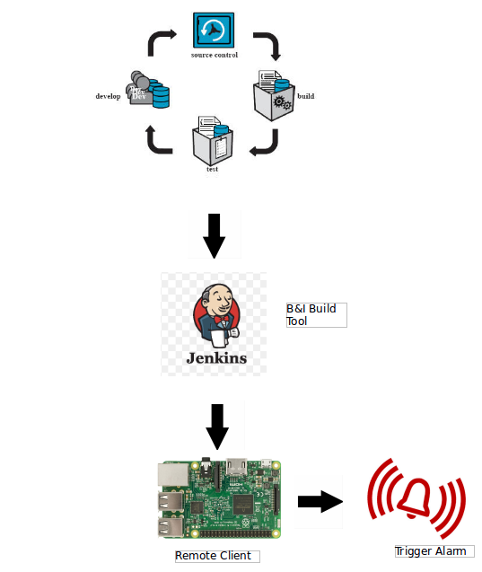

# Design

## Flowcharts

→ Flow Chart for B&I

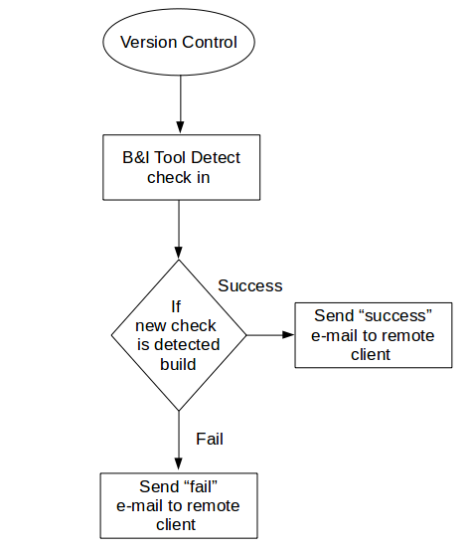

→ Flow Chart for Remote Client

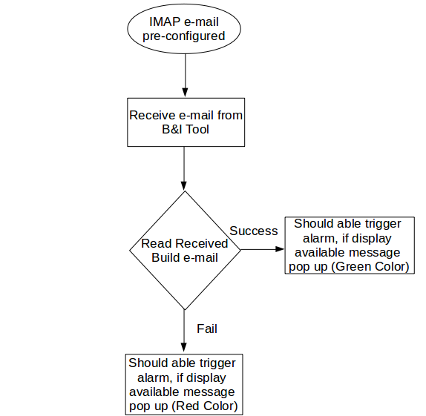

## Development Environment

* Vim Editor
* Python Compiler
* GCC

# Implement

## System Requirements

### Functional Requirements

|  |  |  |
| --- | --- | --- |
| SL # | Requirements | Description |
| 1 | REQ - B&I001 | B&I Tool should detect check in’s from version tool |
| 2 | REQ – B&I002 | B&I Tool should able to build |
| 3 | REQ – B&I003 | B&I Tool should able to send the result of build process to pre-configured e-mail id |
| 4 | REQ – B&I004 | if build success send SUCCESS e-mail to remote client and run test scripts, generate report |
| 5 | REQ – B&I005 | if build fail send FAIL e-mail to remote client |
| 6 | REQ – B&I006 | Remote Client should be pre-configured with IMAP e-mail client |
| 7 | REQ – B&I007 | Remote Client should able to read recevied e-mail |
| 8 | REQ – B&I008 | Remote Client should able to trigger alarm/flash message on receiving “SUCCESS” mail (Green pop up) |
| 8 | REQ – B&I009 | Remote Client should able to trigger alarm/flash message on receiving “FAIL” mail (Red pop up) |
| 9 | REQ – B&I010 | if screen/display available remote client will play alarm with message pop up on screen until user manually |

|  |  |  |
| --- | --- | --- |
| 10 | REQ-B&I011 | if screen/display not available remote client will play alarm for per-defined time i.e 60 seconds |

## User Acceptance Criteria

B&I tool should able to detect check in’s from version control and build the check in and send build status to remote client, remote client should read e-mail and trigger alarm if “Build FAIL” e-mail is received.